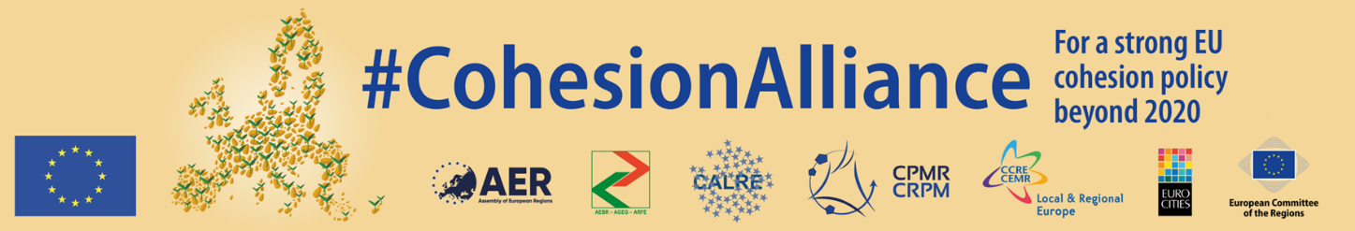

|  |
| --- |
| **#COHESIONALLIANCE CONFERENCE**  **"Together for a strong Cohesion policy 2021-2027"**  **Wednesday, 10 July 2019, 15:30-18:00**  **at the**  **European Committee of the Regions**  **Rue Belliard 99-101, B-1040 Brussels**  **Room JDE 51**  **followed by a networking reception in Atrium 5** |

**DRAFT PROGRAMME**

Cohesion policy is the key European instrument for promoting economic, social and territorial cohesion within the European Union and is one of the most visible EU policies at local and regional level, demonstrating the benefits of Europe to its citizens. In light of the discussion on the future of cohesion policy after 2020, the leading European associations of cities and regions and the European Committee of the Regions launched in October 2017 the #CohesionAlliance, a growing coalition of more than 450 institutional partners and more than 11.000 individual supporters, who believe that cohesion policy must continue to be a pillar of the EU's future. The alliance demands that the EU budget after 2020 makes cohesion policy stronger, more effective, visible and available for every region in the European Union.

One year after the presentation of the cohesion policy legislative proposals for the years 2021-2027 by the European Commission, the European Parliament has finalised its position at first reading on the matter just before the end of the Parliamentary term and the Council has agreed on partial negotiating mandates on most parts of the legislative package. The negotiations on the various dossiers will resume in autumn 2019, under a new European Parliament and with a new Commission.

Against this background, the conference will bring together representatives from the wide range of #CohesionAlliance partners, in order to take stock of the achievements so far and to send a strong message to the upcoming European Commission, the new Parliament and the Council on the importance of a strong cohesion policy for the future of the European Union and on the necessity to shape the future cohesion policy in a genuine partnership with all relevant partners.

**Programme**

**Moderation:**

* Name tbc

**15:00 Registration of participants**

**15:30 Opening**

* Mr Karl-Heinz Lambertz, President of the European Committee of the Regions

**15:40 Introduction: Achievements of the #CohesionAlliance**

* Mr Michael Schneider, CoR rapporteur on "The future of Cohesion policy beyond 2020" and co-rapporteur on the "Common Provisions Regulation"

**15:50 Panel 1: The role of cohesion policy for achieving the EU's strategic objectives**

Further to the informal summit on 9 May 2019 in Sibiu, where EU Heads of State or Government started a discussion on the EU's priorities for the coming years, the European Council adopted on 20 June 2019, just ahead of the new institutional cycle, the EU's Strategic Agenda for 2019-2024, setting out the overarching priorities that will guide the work of the EU over the next five years. Cohesion policy is the EU's long-term investment policy for all regions in Europe to support growth and jobs at local and regional level, by promoting innovative solutions for issues such as climate change and energy transition, social inclusion, as well as for cross-border, transnational and interregional co-operation. As the EU's key investment policy, it could also provide a significant contribution for achieving the Sustainable Development Goals (SDG's) in the European Union, which was also acknowledged by the European Commission in its EU reflection paper on "Towards a Sustainable Europe by 2030".The first panel discussion will therefore highlight the need for a strong and adequately financed cohesion policy and the role that it can play in implementing the SDG's and in achieving the strategic objectives of the European Union.

Moderated discussion with the following participants:

* Ms Corina Crețu, Member of the European Parliament (tbc)
* Mr Enrico Rossi, Vice-President of the Conference of Peripheral Maritime Regions (CPMR)
* Ms Nicola Schelling, President of the METREX Network of European Metropolitan Regions and Areas
* Mr Radim Sršeň, Member of the Council of the European LEADER Association for Rural Development (ELARD)
* Mr Julije Domac, President of FEDARENE (European Federation of Agencies and Regions for Energy and the Environment) (tbc)
* Mr Ville Majamaa, Vice-President of the European Youth Forum

**16:45 Panel 2: The importance of the partnership principle for the successful programming and implementation of cohesion policy**

A successful delivery of cohesion policy requires the strengthening of the partnership principle and the place-based approach by reinforcing the key role of local and regional authorities and actively engaging urban and rural communities and other partners. The European Parliament, in its position on the cohesion policy legislative package, put a strong emphasis on partnership and called for mandatory Partnership Agreements for all Member States. On the other hand, the Council's partial negotiating mandate suggested to significantly weaken the provisions covering the partnership principle and the elaboration of the Partnership Agreements for the European Structural and Investment Funds. The second panel therefore aims at highlighting the importance of the principles of multi-level governance and partnership and the necessity to shape the future cohesion policy in a genuine partnership with all relevant partners.

Moderated discussion with the following participants:

* Ms Constanze Krehl, Member of the European Parliament
* Mr Magnus Berntsson, President of the Assembly of European Regions (AER)
* Mr Christoph Leitl, President of Eurochambres (tbc)
* Mr Per Hilmersson, Deputy General Secretary of the European Trade Union Confederation (ETUC)
* Ms Roberta Dall'Olio, President of the European Association of Development Agencies (EURADA) (tbc)
* Ms Veronique Willems, Secretary General of SMEUnited

**17:40 Closing and future outlook for the CohesionAlliance**

* Ms Isabelle Boudineau, Chair of the CoR COTER Commission

**18:00 Networking reception (Atrium 5)**

**Interpretation: 5/5 EN/FR/DE/PL/IT**

**_________________**